Queries for use cases

Student

* Register for a course: chathuni

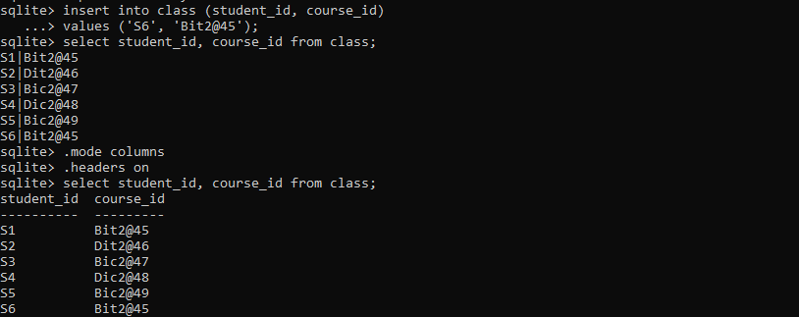

* View enrolled course: chathuni



* View grade: chathuni

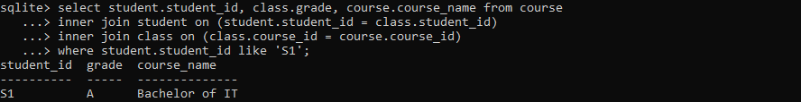

* View payment details: chathuni

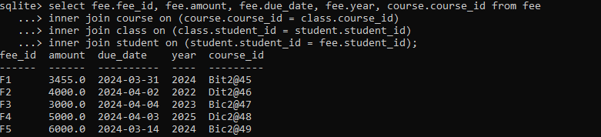

* View their details: chathuni



Lecturer

View courses:vivek



Grade students in a course: vivek

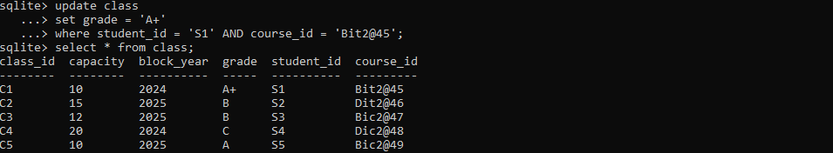

Generate the report card: vivek

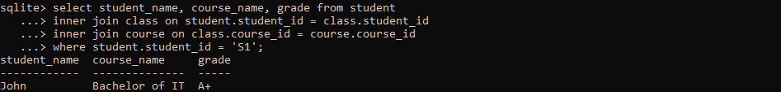

View student records: vivek

Edit student grade:

Administrator

Register a new student: chathuni

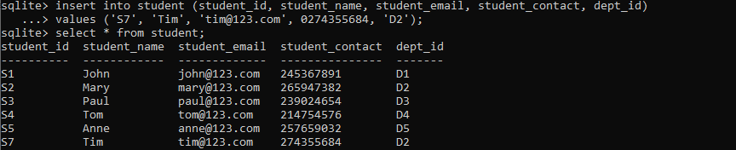

View student records: chathuni

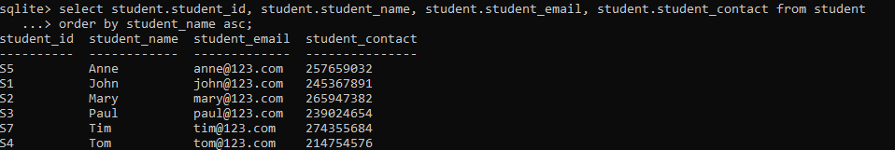

View courses: vivek

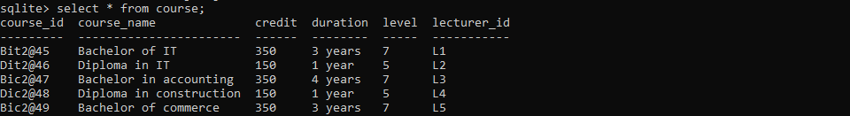

Update course: vivek

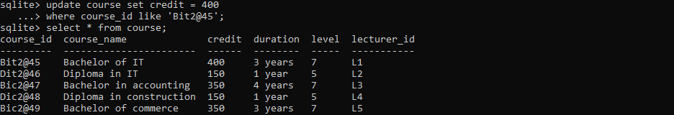

Add a course:vivek

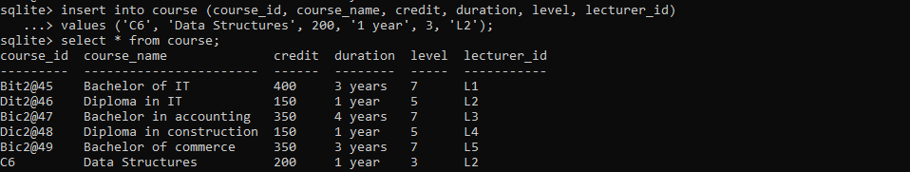

Remove a course:vivek

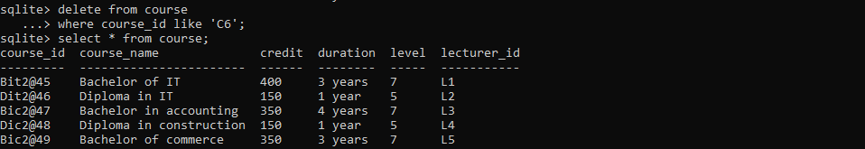

View payment details:vivek

